Kevin Valenzuela

October 28, 2018

Digital Image Processing

Assignment 5

For this assignment I had to take a full body picture that I have of mine. I have one of my posing next to the Google office in Boulder, Colorado. The image can be seen below.

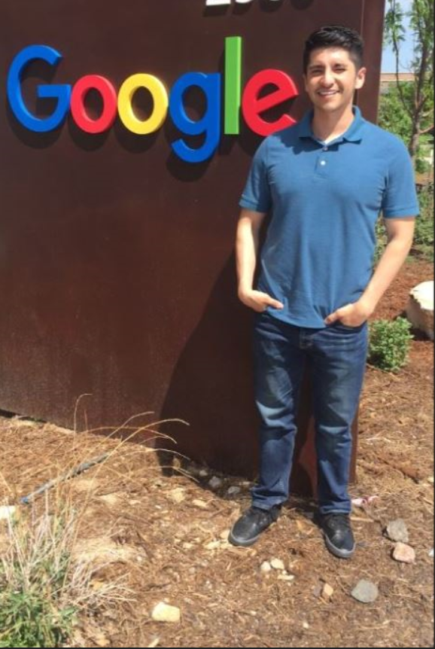

To detect my face, I used the code that was provided from the last assignment to detect the skin. I also tried to get rid of some illumination because I had troubles getting rid of the O’s in Google and the E as well. For some reason, maybe the color and shape of the letters are very similar to face color and shape. In the end I had to make that part of the image into black.

I ran into another problem that I have not been able to resolve. A region behind my face keeps appearing and I haven’t been able to crop out just my face. Not even illumination correction was able to solve it. I will have to continue to find a way to get rid of the weird shape next to my face.